**Smart Street Light Proof of Concept**

**Midterm Report**

EEL 4911C

10/29/15



Team #: 9

Faculty Advisors:

Dr. Jerris Hooker

Authors:

Tucker Russ (tr13f@my.fsu.edu)

Thor Cutler (tc11f@my.fsu.edu)

Brandon Berry (brandonberry@gmail.com)

Anthony Giordano (afg11@my.fsu.edu)

**Table of Contents**

**Abstract3**

1. **Introduction3**
2. **Project Specifications4**

2.1 Project Scope**4**

2.2 Design and Analysis**5**

2.3 Project Definition**8**

1. **Methodology17**
   1. Resource Allocation**17**
   2. Results**18**
2. **Conclusion20**
3. **References21**

**Abstract**

The objective of this midterm report is to update on the progress of the Smart Streetlight senior design project. This report outlines the process by which design choices were made and the factors that influenced these decisions. Calculations related to design choices are outlined in this report and explained using decision matrices. Several important decisions have been made about the design of the streetlights based on the comparison of many key factors. User Interface, lighting specifications and design display are all considered in the design of the system. A basic design for each of these components has been chosen from several proposed designs, and will go on to be tested and prototyped in future iterations. The next step of the project is to begin the assembly of a functioning prototype and to begin testing. Once testing has begun, the designs will be reevaluated and solutions will be proposed for any unforeseen problems.

**Introduction**

Currently, when a streetlight looses power, it does not have the ability to alert the utility of the outage. A customer must call to report the outage. A contributing factor to this is old outdated technology that has not been improved or updated in decades. The Smart Streetlight project is a design that will change this. When an outage occurs on the streetlight, the status will be transmitted to a user interface that will relay the information to the user. In addition, it will allow the location of the outage to be known, which will greatly improve restore times and allow more information to be determined. For example, multiple outages on the same fuse. Another benefit of this project is replacing the traditional streetlight bulbs with LEDs. This will lead to lower energy costs, maintenance, and less CO2 emissions. The streetlights or household power status will communicate through a wireless XBee network and connect peer to peer in order for their current statuses to be accessed. A node placed on each street light will communicate wirelessly with a single central station where the information will then be accessible on a user interface. The signal will travel through a mesh P2P network allowing for increased range.

**Project Scope**

The Smart Streetlight project, is funded by the Entrepreneurial Senior Design department. In addition to the other general senior design requirements, the final design will present the cost and benefits of implementing Smart Streetlights on campus. As depicted in figure 1, Florida State University campus is outlined with the Smart Streetlight infrastructure which forms mesh connectivity with other Smart Streetlights. Additionally, Smart meters will also have the ability to connect. This gives the added functionality to allow Smart meters relay the same outage notification capabilities that the Smart Streetlights use, all on one network. The reason why we chose a college campus like Florida State University is because of the amount of streetlights spread throughout one area. Later on we will develop a business model on how our project could potentially be brought to other campuses in hopes of other colleges adopting this technology. In order to make this possible we chose to build our design on a portable rolling cart. The cart would serve as the platform for our entire design and allow all the components to be easily seen and understood during the demonstration. Additionally, there will be a single detached Smart Streetlight that would be set up at a distance apart from the cart. This would further demonstrate the P2P mesh network and how signal would hop between devices.

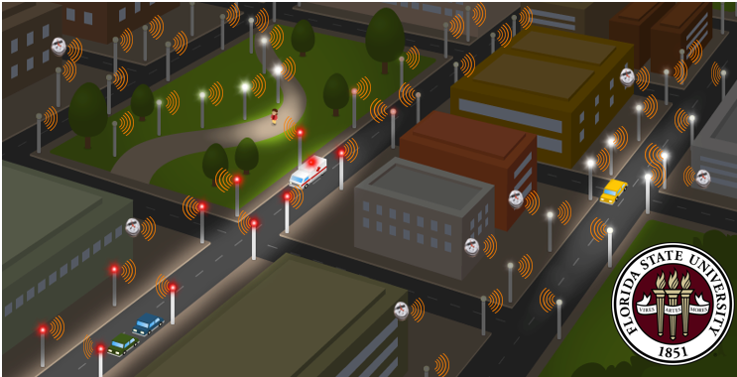

Figure 1-1 – Smart Streetlights on Campus

**Design and Analysis**

* 1. **Functional Analysis**
     1. **System Design**

The System Design Portion of our project is the key component of our project, and while it will not produce a working full-scale streetlight device, it will act as a proof of concept showing how this technology could work.

To create the mesh network we have chosen to use XBee Series 1 devices. XBee devices were chosen due to ease of use and their low cost. While we’ve chosen to use series 1 XBee devices, there are many other models with increased range that could be used if the real world street lights were further apart. There will be one XBee device per light, powered by the same source as the light. If the light loses power, the XBee will run off of a battery to remain on and send the status of the light to the User Interface

To create a user interface (UI) a Raspberry Pi was chosen. I chose the Raspberry Pi because it runs on a basic Linux Operating System, and I am also familiar with its various capabilities such as its GPIO Pins. Using the Raspberry Pi in conjunction with a touch screen will create an easy to use interface that will be capable of showing the status of all modified devices

* + 1. **Model Design**

The model design part of our project encompasses all the tasks relating to making the display that will be show during our final presentation. This part of the project must be able to encase the Smart Street Light System (SSLS) explained above and have various peripherals (such as demo street lights) that would allow testing of the SSLS. Our model will be built on a cart allowing it to be mobile. While our requirement states that we need two street lights to be represented on the cart, we would also like there to be a third one not connected to the cart to better demonstrate the wireless capabilities of the SSLS. The model portion of our overall design, while not as technical as the system design, is important because it allows us to visually show how this system could work in a real-world setting.

* 1. **Design Needs**

|  |  |
| --- | --- |
| Need Code | Need Statement |
| N_E1 | The system must save money over time |
| N_S1 | The user must be alerted when a light loses power |
| N_S2 | The user must be alerted when a house loses power |
| N_S3 | The system must display current light status |
| N_S4 | The system must display current house status |
| N_S5 | The system must be able to communicate wirelessly with a light |
| N_S6 | The system must be able to communicate wirelessly with a house |
| N_S7 | The system must be able to communicate with each light individually |
| N_S8 | The system must update user information semi continuously |
| N_M1 | The model must have both a light and a house represented |
| N_M2 | The model must have a screen to display user information |
| N_M3 | The model must be portable |
| N_Want1 | The system may display a lights current voltage and current. |
| N_Want2 | The system may be more environmentally friendly than the current system |
| N_Want3 | The system may display how long a light has been without power |
| N_Want4 | The system may display how long a house has been without power |
| N_Want5 | The model may represent an actual street |
| N_Want6 | The model may have a touch screen |
| N_Want7 | The system may store status information on the internet to be accessed remotely |

Table 1-1 – Design Needs

* 1. **Design Requirements**

|  |  |  |  |
| --- | --- | --- | --- |
| Requirement Code | Requirement Statement | Need Mapping | Explanation |
| R_S1 | The SSLS shall alert a user within 10 seconds of a smart-meter or streetlight losing power. | N_S1 N_S2 | The purpose of this requirement is to document one of the basic functions of our project. When a street light or smart meter loses power, the system user, by looking at the system’s monitor, will be alerted of the power loss. |
| R_S2 | The SSLS shall constantly show the status of all monitored devices, updating every 10 seconds.  Status consists of:  -Powered on or off  -last updated  -voltage  -current  -power | N_S3 N_S4 N_S8 N_Want1 N_Want3 N_want4 | The purpose of this requirement is to ensure that the system will constantly be updating data on a set time interval and not just when a monitored device loses power. |
| R_S3 | The SSLS shall receive status signals from monitored devices wirelessly. | N_S5 N_S6 N_S7 | The purpose of this requirement is to simulate that street lights are far enough apart that a wired connection isn’t practical |
| R_S4 | The SSLS shall be able to differentiate between different lights by the signal that they send. | N_S7 | The purpose of this requirement is to ensure that each light sends a slightly different signal as to allow the user to know which light has lost power. |
| R_M1 | The SSLS Demo Model shall be built on a cart making it mobile. | N_M3 | Our whole demo will be built on a cart allowing presentations to be held in multiple locations and making working on the Demo easier. |
| R_M2 | The SSLS Demo Model shall have a monitor to display the status of all monitored devices. | N_M2 N_Want6 | The Demo will have the screen that displays the SSLS information for each light covered in R1 and R2. |
| R_M3 | The SSLS Demo Model shall have at least 1 street light and 1 smart meter that can be shut off to represent power loss. | N_M1 | This part of the model will be used to represent power loss in a light allowing us to display how the system reacts to power loss in a monitored device. |

Table 1-2 – Design Requirements

**Project Definition**

a) Background research

XBee Series 1:

The team will design a model of the Smart Streetlight network using three XBee wireless modules in order for each light to communicate. The XBee was chosen by the team because of it is good for point-to-point, multipoint and convertible to a mesh network. They are able to automatically sync and pass data back and forth, which will allow the user to recognize the status of the power.

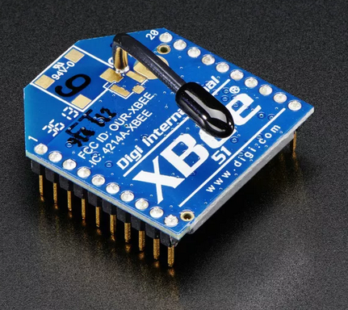

Raspberry Pi 2: The Raspberry Pi 2 is used because of its ability to connect to a LCD and to perform Linux based operations to control the User Interface of the Outage Management and control over the Xbee Devices. The devices can be easily connected to the Pi via a USB controller.

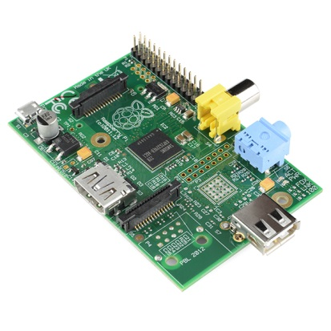

DC Power Supply: Each streetlight will be powered separately by a DC power supply shown in figure 1-7 this will allow power to both the XBee and LEDs on the streetlight.

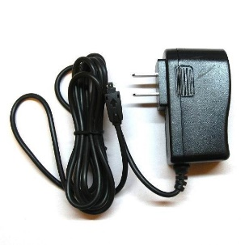

LED Lights: A single 120 LED 3528 will be used on each Streetlight which will provide a 360 degree bulb like light with the advantages of low consumption LEDs.

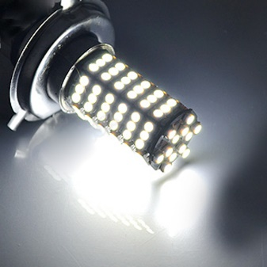

b) **Needs Statement**

In the event that power is lost in a specific household or streetlight the system must be alerted and be able to display the current status. The communication of the power status must be wireless and be able to update user information semi continuously. This communication system is necessary in order for the user to save time and money.

c) **Objectives and Goals**

The team will design a portable small-scale model of the Smart Streetlight system in order to demonstrate its functionality. This will allow the team to easily transport the model around in order for it to be worked on and tested. The model will represent both the household and the streetlight, along with a screen to display the user information.

**Constraints**

|  |  |
| --- | --- |
| Budget | $2,000 |
| Deadline | Mid-Spring |
| Power | DC Power Supply |
| Control | Integrated RaspBerry Pi |
| Display | Portable Cart w/ wheels |
| Goal | Have wireless communications with Streetlights and convert outdated gas fixtures to LED |

Table 1-3 – Constraints

a) **Design Specifications**

The mesh network using the three XBees should run as smoothly and efficiently as possible. Each xBee module should be able to update their statuses to a single source continuously in order to stay as up to date as possible. This is important because during a real life, large scale power outage, the utility must act to restore the outage as soon as possible.

b) **Performance Specifications**

The mesh network created by XBees must have the ability to run 24/7. In addition to this the network must have the functionality to not be limited by a certain number of devices. The number of devices should be almost unlimited as large networks will be created using this technology. There will be some sort of delay in changing status from online to offline and vice versa. This delay should be kept under 1min optimally as the user should know the status change as soon as possible.

**LEDs vs. HPS Cost**

|  |  |  |
| --- | --- | --- |
|  | **LED** | **HPS** |
| **Initial Cost** | $600 - $800 | $400 - $500 |
| **Avg. Power Cost Per Year** | $37 - $73 | $109 - $146 |
| **Overall Lifetime Cost Per Year** | $80 - $131 | $167 - $219 |

Table 1-4 – LED vs HPS Cost

**Overall Lifetime Cost Per Year:**

*= [[[Bulb lifetime / (365days X 10hrs)] X Power Cost Per Year] + Initial cost] / Bulb lifetime*

We can see from the “overall lifetime cost per year” of each light that it would be twice as cost efficient to go with a LED bulb over the traditions HPS bulbs. Although the initial cost of the LEDs are more than that of the HPS bulbs, it is easy to see that over a long period of time the costumer would save a great deal of money by going with LEDs.

**LEDs vs. HPS Performance**

|  |  |  |
| --- | --- | --- |
|  | **LED** | **HPS** |
| **Power Use** | 100W – 200W | 300W – 400W |
| **Brightness** | 10,000 – 20,000 Lumens | 22,000 – 30,000 Lumens |
| **Wavelength** | 4000K – 5500K | 2200K |
| **Lumens Per Watt** | 100 Lumens/Watt | 76 Lumens/Watt |

Table 1-5 – LED vs HPS Performance

From the table above we can see that LED bulbs produce more light per watt. This overall will save money as less power is needed to produce the same amount of light. We can also see that the wavelengths of LED bulbs are closer to true white than that of HPS bulbs. The figure below shows a comparison of the lights and where they fall compared to natural light.

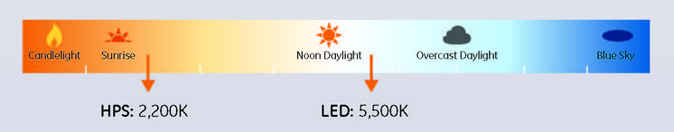

**LEDs Vs. HPS Maintenance**

|  |  |  |
| --- | --- | --- |
|  | **LED** | **HPS** |
| **Lifetime** | 50,000 hrs | 20,000 – 25,000 hrs |

Table 1-6 – LED vs HPS Cost

The longer lifetime of the bulbs translates into less maintenance needed to keep the lighting. Not only does the replacement of the bulbs cost money, but so does paying someone to replace or repair a light fixture. From the above table it is easy to see that a HPS bulb would need replacing twice as often as a LED bulb.

**LED vs. HPS Bulbs Matrix**

|  |  |  |  |  |  |
| --- | --- | --- | --- | --- | --- |
|  | **Cost** | **Performance** | **Maintenance** | **Geom. Mean** | **Norm. Weight** |
| **Cost** | 1 | 2 | 3 | 1.82 | 0.55 |
| **Performance** | ½ | 1 | 3/2 | 0.91 | 0.27 |
| **Maintenance** | 1/3 | 2/3 | 1 | 0.61 | 0.18 |

Table 1-7 – Led vs HPS

**Raspberry Pi. Vs. Arduino Matrix**

|  |  |  |  |  |  |
| --- | --- | --- | --- | --- | --- |
|  | **Cost** | **Performance** | **Size** | **Geom. Mean** | **Norm. Weight** |
| **Cost** | 1 | 2 | 3 | 1.82 | 0.55 |
| **Performance** | ½ | 1 | 3/2 | 0.91 | 0.27 |
| **Size** | 1/3 | 2/3 | 1 | 0.61 | 0.18 |

Table 1-8– LED vs HPS Cost

For the XBee to still be able to communicate if the supplied DC power was to ever be lost, we had to design a backup battery circuit. Because the XBee will be using the supplied DC power as an input check, we had to make sure the backup battery wouldn’t give the XBee a false reading of the supplied DC power was still on. This is done through the use of rectifier diodes that only allow the flow of current in one direction.

The diodes not only prevent the current from flowing from the backup battery to the XBee check, they also reduce the supplied 5 volt DC power down to 3.3 volts needed to run the XBee.

A 25 ohm resistor is used in series with the SMD 5050 LED in order to reduce the current going into the LED to just over 60mA. This allows the LED to get the proper current without being over heated.

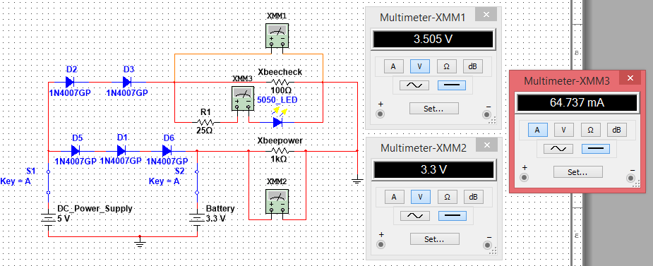

Figure 1-3 - Backup Battery Circuit While DC Power is connected

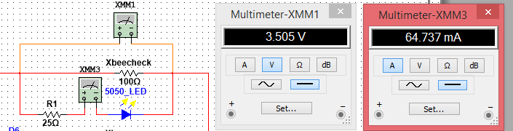

Figure 1-4: Voltage @ LED & XBee Check and Current through LED

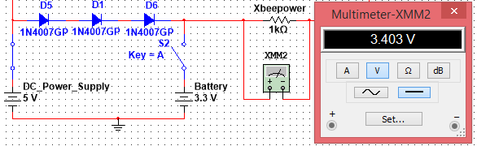

Figure 1-5: XBee Power & Battery Charging Voltage

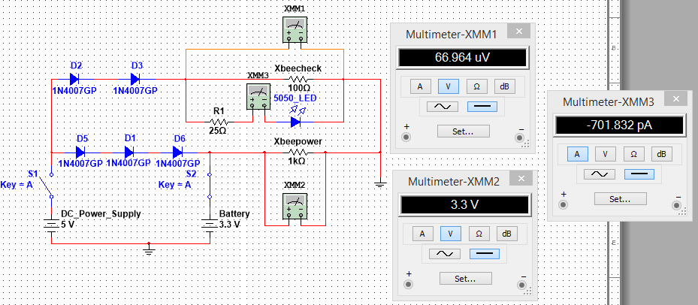

Figure 1-6: Backup Battery Circuit While DC Power is disconnected

We can see from the above figure 4, once the DC power has been disconnected from the circuit, the XBee power still receives the needed 3.3 volts while the XBee check has dropped to near 0 volts. Also notice the LED has turned off as well. The LED will be connected to a separated check on the XBee so it can notify when the LED has gone out but the power is still on.

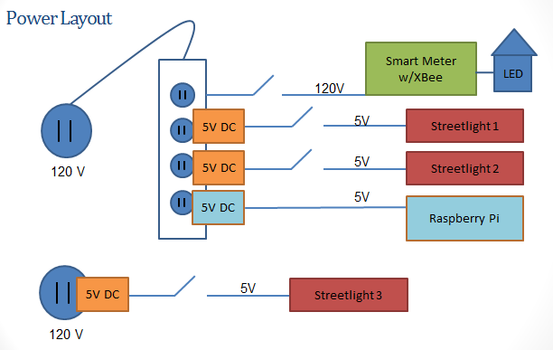

Figure 1-7: Power Layout on Cart

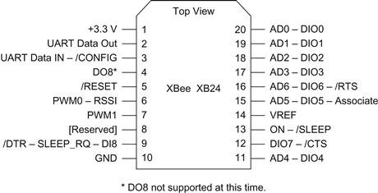

Figure 1-8: 6 Pinout of Xbee Series 1

**Work Breakdown Structure**

|  |  |  |  |  |  |  |  |
| --- | --- | --- | --- | --- | --- | --- | --- |
| ID | Activity | Description | Deliverables | Duration (days) | People | Resources | Predecessors |
| 1 | **Communication** |  |  |  |  |  |  |
| 1.1.1 | Xbee P2P Connectivity | Complete connection between 2 xbee devices | Circuit schematic  Simulation Verification | 31 | Tucker(1)  Thor(2) | PC  X-CTU  Simulator |  |
| 1.1.2 | Xbee Mesh Connectivity | 2 xbees must be paired in a mesh network | Circuit schematic  Simulation Verification | 83 | Tucker(1)  Thor(2) | PC  X-CTU  Simulator | 1.1.1 |
| 1.2 | **LED Circuits** | Build and test. |  |  |  |  |  |
| 1.2.1 | Power LED’s | Test LED functionality on Power source | Circuit  Schematic  Simulation  Verification | 90 | Brandon (1)  Anthony (2) | Voltage test bench in Lab |  |
| 1.2.1 | Mount LED’s and xbee | Create a fixture to mount the LED and xBee to | Design  Drawing  Built Product | 97 | Brandon (1) | Possible 3D printing  Legos, etc | 1.1.1  1.2.1 |
| 1.3 | **Power Supply** |  |  |  |  |  |  |
| 1.3.1 | Test DC Power supply | Make sure there is enought output voltage connections for the entire system | Test each output must power all xBee and LED devices | 24 | Anthony (1) | Test bench with multimeter | 1.2 |
| 1.4 | **Raspberry Pi** |  |  |  |  |  |  |
| 1.4.1 | xBee connectivity | Connect an Xbee to the Raspberry Pi to bring in data from other Xbee devices | Circuit  Schematic  Simulation  Verification | 21 | Thor (1)  Tucker (2) | Rasp Pi  Xbee  Xbee USB controller  PC  X-CTU | 1.1.1 |
| 1.4.2 | Outage Notification | Show status of a single Xbee on the Rasp Pi | Simulation  Verification | 129 | Thor(1)  Tucker(1)  Brandon (1)  Anthony (1) | Rasp Pi  Xbee  Xbee USB controller  PC  X-CTU | 1.1.1  1.4.1 |
| 1.4.3 | Outage Notification Mesh | Show status of each Xbee on the Rasp Pi | Simulation  Verification | 142 | Thor(1)  Tucker(1)  Brandon (1)  Anthony (1) | Rasp Pi  Xbee  Xbee USB controller  PC  X-CTU | 1.1.1  1.4.1  1.4.2 |

Table 1-9: Work Breakdown Structure

**Resource Allocation**

In order to more efficiently accomplish the goals set for the group in both the Schedule section and the Gantt chart (Appendix A), group members have been assigned to different categories of tasks that best suit their skills. XBee connectivity has been assigned to Thor and Tucker because they both have the technical background in programming and have done the most research on the XBee devices. This is the most important part of the project as everything must be connected in order for the design to function, once the XBees have been connected and the basic coding has been implemented to control them Thor will begin to incorporate the Raspberry Pi to have functionality with the XBees. Tucker functions as the team leader who finalizes documents and schedules meetings with the team members and advisors. He will also work on whichever portions of the project needs more help. Brandon will be assigned to the LED lighting aspects of the design. Brandon has worked extensively with LEDs in the field and even designed LED fishing devices. In addition he will also create the model of how everything will be set up and displayed on the cart. Anthony will work on providing power to all the devices on the cart. He will also be assigned to implementing a Smart Meter in the design and testing different ways the XBees will connect to the Smart Meter. Anthony has always had a fascination with power systems and has carefully researched which power supplies would work best for the design. Finally, the entire team will be working on the prototyping phase, as it will require all aspects of the project working together. Below, table 6 illustrates which group members have been put in charge of which tasks and how much time each member has allocated to complete it. These assignments do not prohibit other members from working on certain tasks, it simply names the group members responsible for their completion.

|  |  |  |
| --- | --- | --- |
| **Name** | **Tasks** | **Time Allotted** |
| Tucker Russ | 10 hours  5 hours  20 hours  XBee Connectivity  Meeting coordinator  Overall Design Leader |  |
| Thor Cutler | User Interface  XBee Connectivity | 15 hours  20 hours |
| Brandon Berry | LED lighting  Model design | 15 hours  10 hours |
| Anthony Giordano | Power Supplies  Smart meter | 12 hours  10 hours |

Table 1-10: Resource Allocation

**Project** **Results**

**Website:**

The team has designed a website that illustrates the basic plan of the project and documents the progress that has been made. Information about the parts and devices to be used can be found while scrolling through the home page. It also gives a brief background of the members in the group and what their main tasks are within the project.

http://eng.fsu.edu/~cutleth/smartstreetlight/index.html

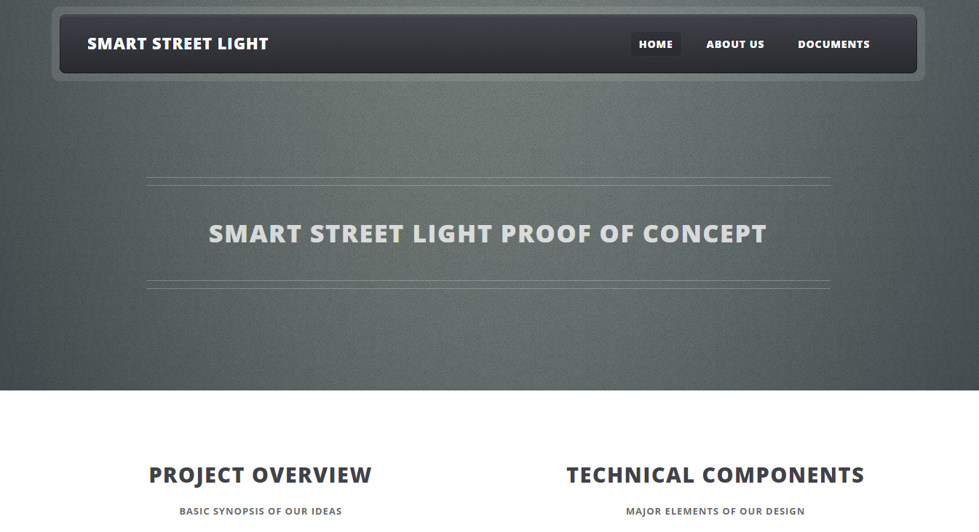

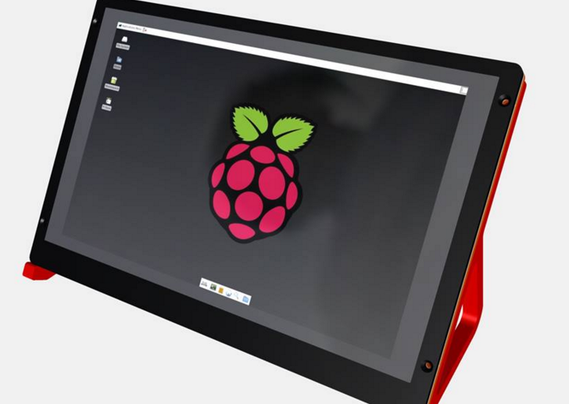Touchscreen for the Raspberry Pi:

The Raspberry Pi 2 is used because of its ability to connect to a LCD and to perform Linux based operations to control the User Interface of the Outage Management and control over the XBee Devices. The devices can be easily connected to the Pi via a USB controller. The Raspberry Pi touchscreen was put together by members of the team. This screen will display the information read from each streetlight and smart meter. It will act as the user interface where data from the network can be obtained at any point in time.

XBee communication between two computers:

The team has purchased two XBee devices with the intention to test their communication abilities between two computers. Sending signals between to the two computers with the use of the XBees was a success which allows the team to move forward with designing the mesh network between the streetlights and smart meter.

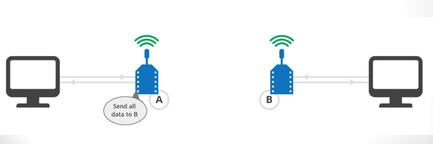

**Risks:**

The team must still take into account any risks and uncertainties that come with the project. It is important for the team to consider all scenarios where problems could be faced. As of now only a few risks and uncertainties have been brought up by the team.

In the event of a power loss to the smart meter, the team is uncertain about the best way to provide it with backup power. It is unclear whether the team will be able to connect a lithium ion battery straight to the smart meter, or if another circuit similar to the ones used on the streetlights will need to be implemented.

Since the team will be working with electricity, it is important to use precaution while working with parts. There has been no hands on electrical work done up to this point, but once progress is made on the project it will be important to practice in lab safety methods when building and testing the model.

**Conclusion:**

The design being developed for Smart Streetlights will operate as a highly efficient network providing lower energy costs, maintenance costs, and CO2 emissions. The streetlights or household power status will communicate through a wireless XBee network and connect peer to peer in order for their current statuses to be accessed. A node placed on each street light will communicate wirelessly with a single central station where the information will then be accessible on a user interface. The overall design of the project has been laid out in order to begin building the Smart Streetlight network model. Through team planning and collaboration, an electrical schematic has been implemented into a well-organized design. Also the parts and devices to be used have been selected and will be ordered within the upcoming weeks.

Wireless communication through the network is the key component of the overall project. Before the team could proceed on into the deeper steps of the project, it was important to first purchase and test two XBee devices in order to prove the use of wireless communication. Once proven, the team was then able to begin planning farther into the design plan. With most of the design drawn out, the team is now about to begin purchasing the parts that will be used to build the model of the Smart Streetlight Network. The team has designed an efficient way to power each device, as well as manually simulate the event of a power loss. A challenge of keeping the smart meter powered in the event of a power loss is still and obstacle that the team faces.

Once the next midterm comes around, the team hopes to have all of the parts ordered the basic design set up. Each device should be connected to its designated power source and the XBees should be communicating wirelessly to the Raspberry Pi. With the system up and running, the next steps will include testing the network to work out any errors that may be encountered, designing the layout for the streetlight model atop the cart, and implement any “wants” that can be added to the project.

Overall the Smart Streetlight project has been making excellent progress. The team has been completing all tasks within a timely manner in order to keep the project on schedule. Even though there is still much work to do, the team expects to have the basic functionality of the project working by the end of the fall semester. Once working, it is expected to simulate a full scale smart streetlight system that will meet the needs of the customer.

**References:**

Tanmay, S., Shue, S., & Conard, J. (2015, April 9). Implementation of Dyamic Source

Routing using 802.15.4 on XBee Series 1 Modules. Retrieved October 9,

2015,http://ieeexplore.ieee.org/stamp/stamp.jsp?tp=&arnumber=7132965&isnum

ber=7132866&tag=1

Urgiles, M., Arpi, P., & Chacon-Troya, D. (2014, August 24). Retrieved from

http://ieeexplore.ieee.org/stamp/stamp.jsp?tp=&arnumber=7294165&isnumber=